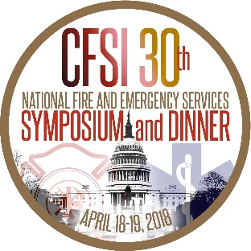

Two Organizations Selected Co-Recipients of the Senator Paul S. Sarbanes Fire Service Safety Leadership Award
The Congressional Fire Services Institute (CFSI) and National Fallen Firefighters Foundation (NFFF) selected the International Society of Fire Service Instructors (ISFSI) and United Laboratories (UL) Firefighter Safety Research Institute (FSRI) as the co-recipients of the Senate Paul S. Sarbanes Fire Service Safety Leadership Award.
The award will be presented at the 30th Annual National Fire and Emergency Services Dinner on April 19, 2018, in Washington, DC. Named after retired-Senator Paul S. Sarbanes of Maryland, a strong advocate for our nation's firefighters and rescue personnel during his 36-year career in Congress, the award recognizes organizations for outstanding contributions to firefighter health and safety. State Farm Insurance and VFIS serve as the corporate supporters of the award program.
For the past ten years, the UL FSRI has been conducting important research on fire behavior in the built environment. The research has examined the impact of modern building construction methods, materials and content on fire behavior. With this research, ISFSI developed a new training curriculum that is changing traditional tactics fire departments have used to fight structure fires. With the goal of translating the science and research into lessons that firefighters (as the practitioners) can understand and implement, the Principles of Modern Fire Attack curriculum has been taught to over 14,000 firefighters in the classroom delivery and has had over 200,000 full length views of the training videos since it was established in 2015.
CFSI President Bill Jenaway and NFFF Chairman Dennis Compton issued a joint statement recognizing UL and ISFSI for their achievements. “Changing the safety culture of fire departments can require changes in firefighting strategy, tactics, decision-making, and behaviors. We commend UL and ISFSI for their collaborative work in both research and training to enhance the performance and safety of firefighters nationwide.”
Both organizations benefited from the Assistance to Firefighters Grant Program, which provided the necessary funding to perform their important work. Congress recently reauthorized the AFG and Staffing for Adequate Fire and Emergency Response (SAFER) grant programs that will enable fire departments and organizations to continue applying for federal grants to address the health and safety of our nation’s fire and emergency services.
Please click here for additional information about the 30th Annual National Fire and Emergency Services Dinner and Seminars Program. Approximately 2,000 fire and emergency services leaders throughout the nation are expected to attend the annual program. In addition to the dinner and seminars, attendees will schedule meetings with their members of Congress to discuss important fire and life safety issues.

