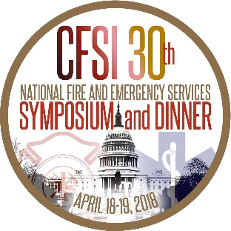

CITY OF ALPENA FIRE DEPARTMENT AND ILLINI EMERGENCY MEDICAL SERVICES TO BE HONORED FOR EXCELLENCE IN EMERGENCY MEDICAL SERVICES
Presentation at the 30th Annual National Fire and Emergency Services Dinner

WASHINGTON, D.C. (March 26, 2018) – The Congressional Fire Services Institute (CFSI) and Masimo will honor the City of Alpena (MI) Fire Department and the Illini Emergency Medical Services with the Excellence in Fire Service-Based EMS Award. The award presentation will take place on April 19th at the 30th Annual National Fire and Emergency Services Dinner in Washington, DC.

First presented in 2011, the Excellence in Fire Service-Based EMS Award has recognized fire departments from across the nation for developing and enhancing the delivery of emergency medical services to address the growing challenges in delivering emergency medical care. By showcasing these practices, the award program provides fire departments across the nation with ideas for enhancing their own fire service-based EMS systems.

The City of Alpena (MI) Fire Department (AFD) is being honored in the career category for innovations in interventional cardiac care. In 2011, the department implemented a fire-based Mobile Intensive Care unit capable of transporting patients to the nearest cardiac care center located 2.5 hours away. The department provides countywide advanced life support (ALS) ambulance response, and in 2013 deployed a non-transporting paramedic unit 20 miles west of the city. It also introduced a High-Performance CPR training program and increased the placement of automatic external defibrillators (AEDs) throughout the community. In 2015, the department expanded the scope of its AED program by creating an AED registry that contains information about AED location, guidance and training. These new initiatives are making a positive difference in cardiac arrest response, increasing the recovery rate of cardiac arrest patients while also enhancing the delivery of non-arrest cardiac prehospital care.

Established in 1978 as a student club, Illini Emergency Medical Services (IEMS) became a student program within the Illinois Fire Service Institute (IFSI) in 2016. IEMS provides non-transport care to the 58,000 students, staff and faculty at the University of Illinois at Urbana-Champaign campus. During its first year as an IFSI program, IEMS initiated a proactive program to improve acute cardiac care capabilities within its service area. Elements of the multi-faceted program included compiling data on AED locations and operational status and conducting Hands-On CPR training at public outreach events. In 2017, IEMS trained 1,297 individuals in CPR – a 206% increase from 2016 – and increased the number of active American Heart Association certified CPR instructors from 16 to 19. The organization also added 42 AEDs around campus filling gaps in coverage and created a system with PulsePoint technology to locate the AED nearest to cardiac arrest victims. IEMS is the recipient in the volunteer/combination category.

“This year, CFSI and Masimo are recognizing two outstanding award recipients for demonstrating leadership and initiative in enhancing their emergency medical services,” said Bill Jenaway, CFSI President. “Both the Alpena Fire Department and Illini Emergency Medical Services were selected for this award for developing innovative programs that addressed certain challenges in the delivery of emergency medical care. We look forward to honoring them for their achievements at the National Fire and Emergency Services Dinner.”

Information about the 2018 National Fire and Emergency Services Symposium and Dinner is available at www.cfsi.org. Tickets are still available for this program which benefits the mission of CFSI.

###

