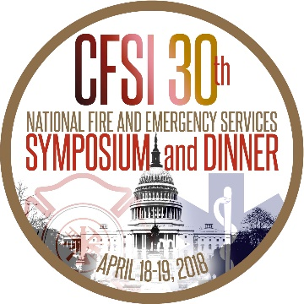

DHS SECRETARY KIRSTJEN NIELSEN TO ADDRESS THE
30TH ANNUAL NATIONAL FIRE AND EMERGENCY SERVICES DINNER
(March 30, 2018) - The Congressional Fire Services Institute is pleased to announce that the Honorable Kirstjen Nielsen, Secretary of the Department of Homeland Security, will address the 30th Annual National Fire and Emergency Services Dinner on April 19, 2018 at the Washington Hilton, in Washington, DC. The theme of the dinner program is “Engaging Future Leaders.” Approximately 1,500 fire and emergency services leaders from across the country are expected to attend the program that pays tribute to the dedication and commitment of our nation’s one million firefighters and emergency services personnel.
Secretary Nielsen was nominated by President Donald Trump on October 12, 2017 to become the sixth DHS Secretary. On December 5th, the Senate confirmed her nomination to lead the third largest federal department, with a workforce of over 229,000 employees, 22 components, and a $47.7 billion budget.
Established in 1989, the Congressional Fire Services Institute is a nonprofit, nonpartisan policy institute designed to educate members of Congress about the role of our nation’s fire service in protecting our homeland. Additional information about CFSI and the dinner program is available at www.cfsi.org.
###

